**Lab 12:**

**MOSFET Amplifier**

Name: Wan-Yu Liao

ECEN 325 Section 514

TA: Mandela

Lab Date: November 22, 2019

Lab Report Due Date: November 27, 2019

**Calculation**

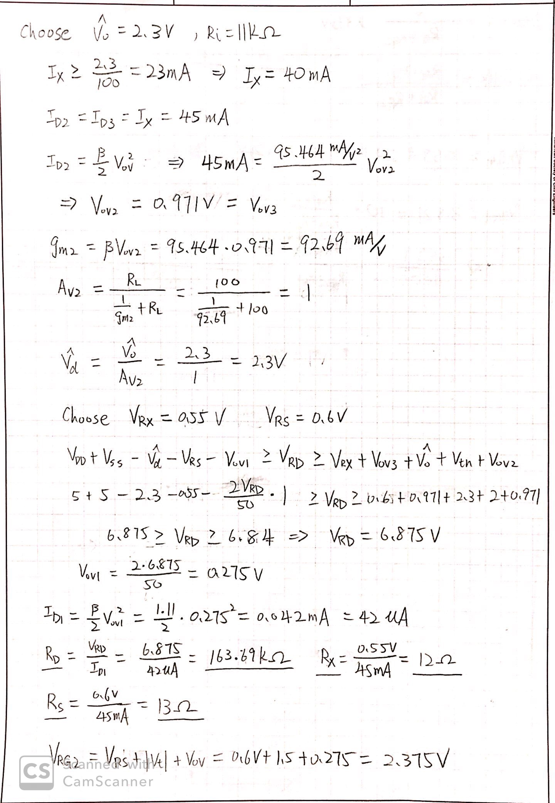

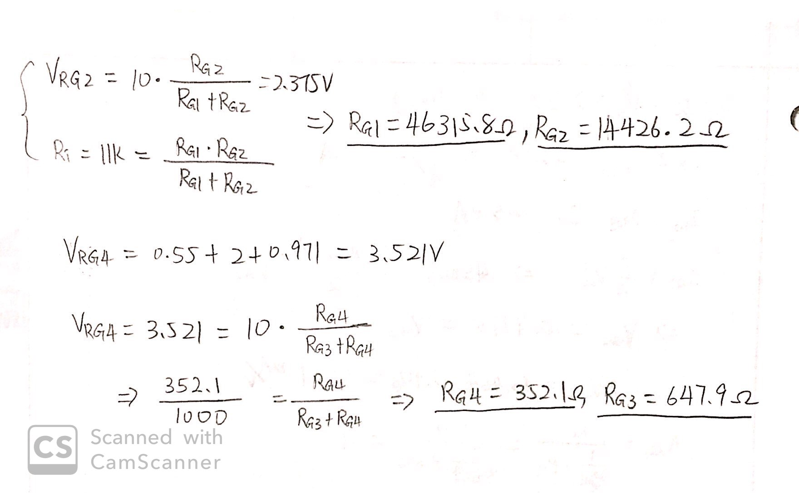

I had the wrong value for Rs.

Rs should be 0.6V/IDA = 0.6/42uA 16kΩ

**Simulation**

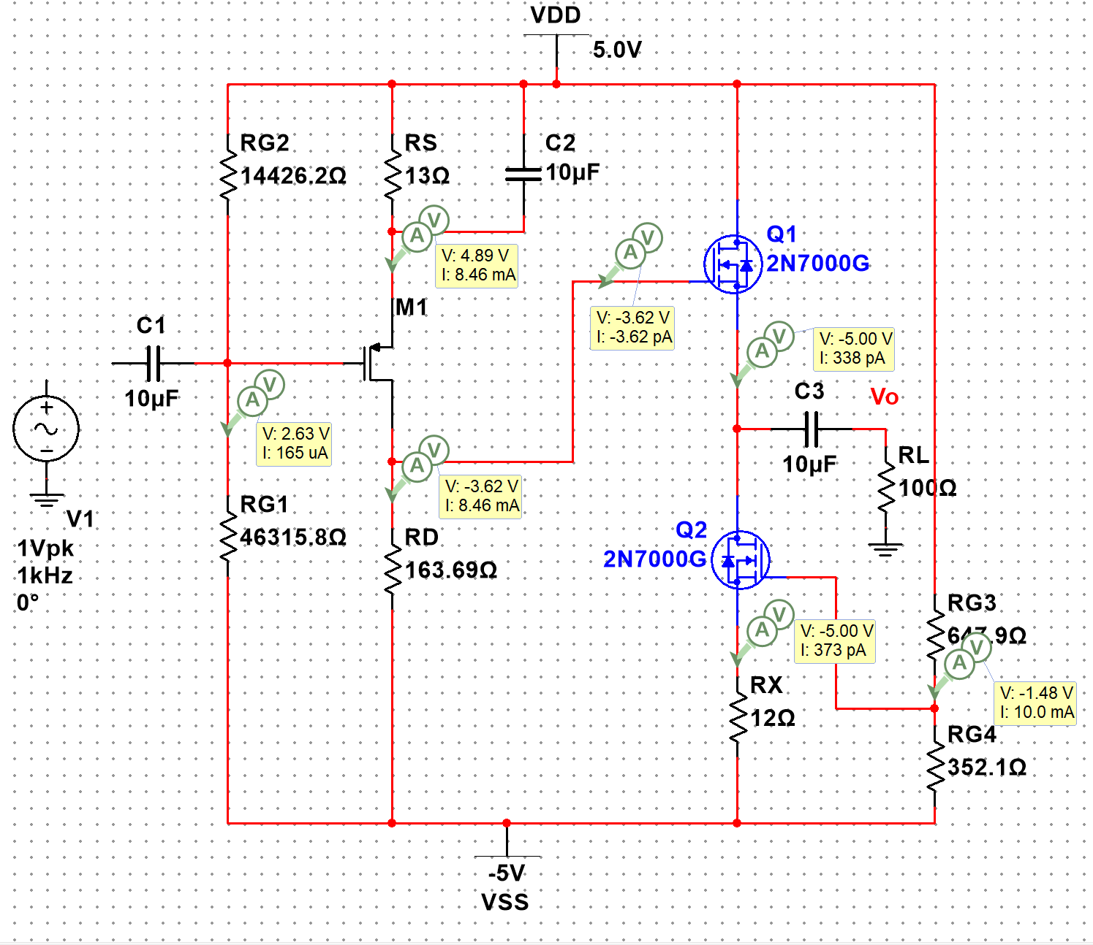

**Figure 1:** DC Solution for MOSFET amplifier ▲

|  |  |  |
| --- | --- | --- |
| VRG1 = 7.63V | VRS = 0.11V | ID1 = 8.46mA |
| VRG2 = 2.37V | VRD = 1.38V | ID2 = 338pA |
| VRG3 = 6.48V |  | ID3 = 373pA |
| VRG4 = 3.52V |  |  |

For this circuit, I got a gain of 0. I rework the circuit.

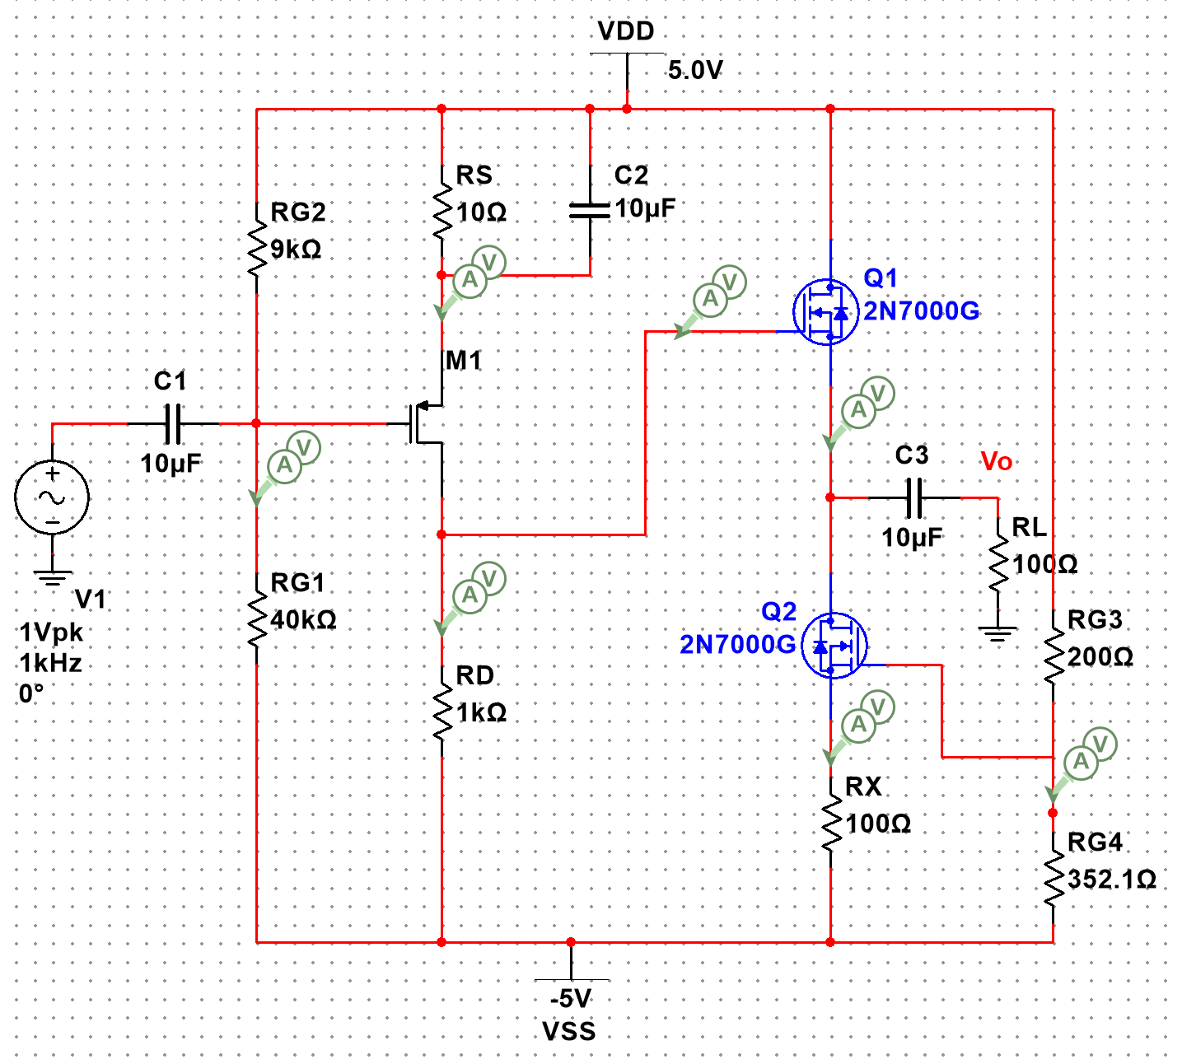

**Figure 1.1:** New circuit for MOSFET amplifier ▲

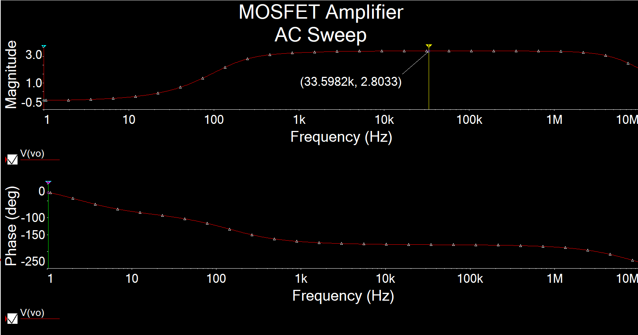

**Figure 2.1:** AC Simulation of AV for MOSFET amplifier ▲

AV = 2.8033

Even I rework the circuit, the best gain I can get is 2.8033.

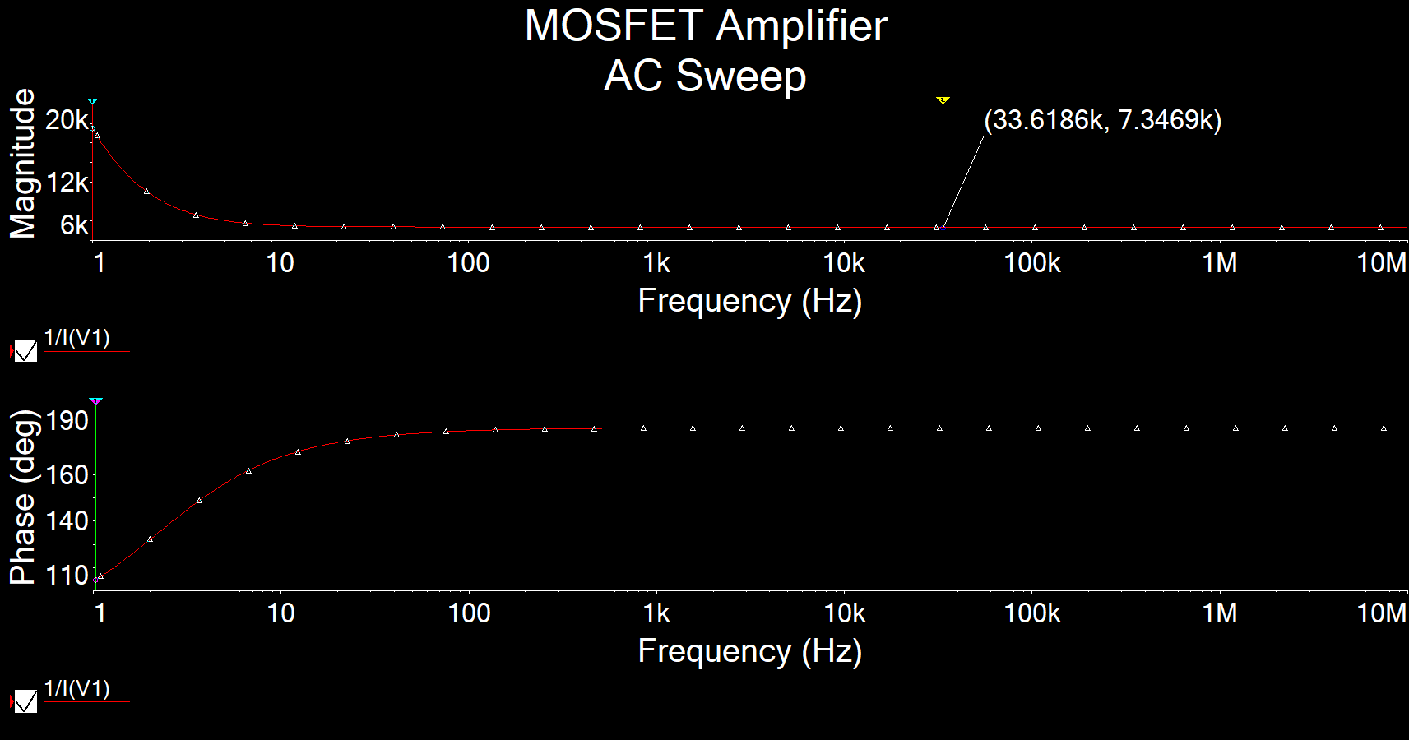

**Figure 2.2:** AC Simulation of Ri for MOSFET amplifier ▲

Ri = 7.3469kΩ

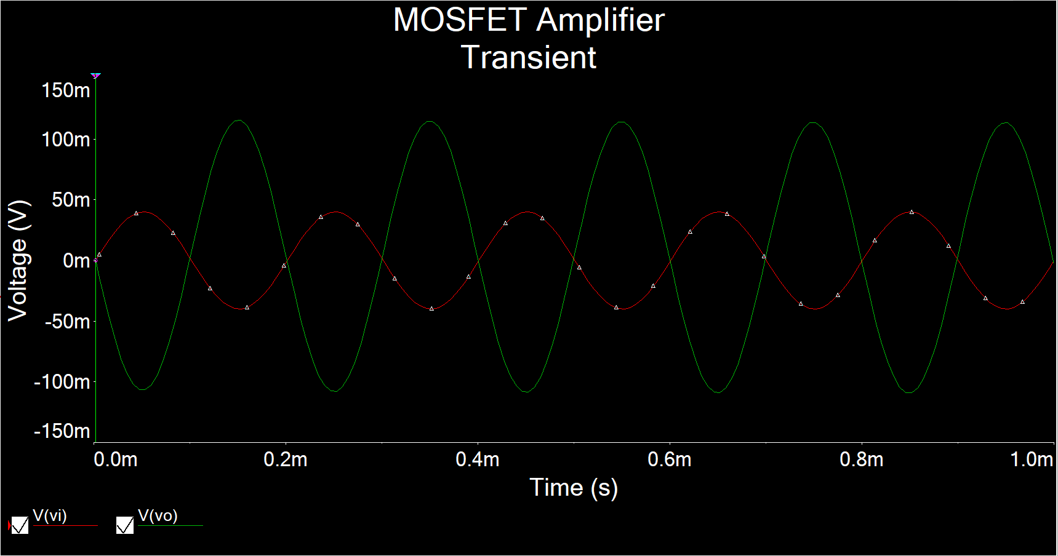

**Figure 3:** Time-domain waveform of Vi = 40mV 5kHzfor MOSFET amplifier ▲

AV

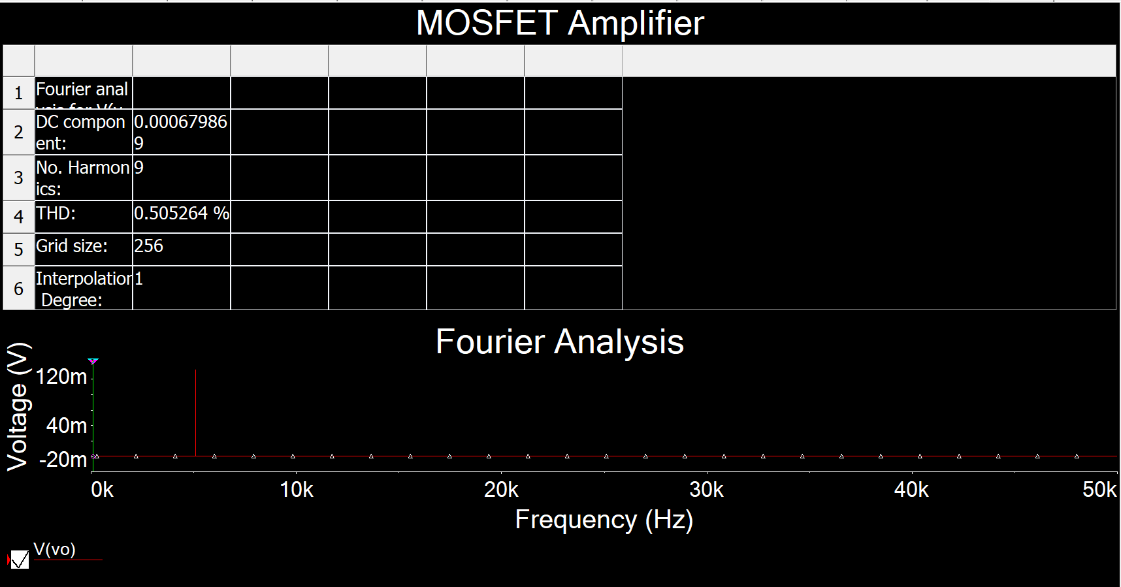

**Figure 4:** Total harmonic distortion (THD) for MOSFET amplifier ▲

THD = 0.5053%

**New Simulation**

I re-work the simulation using the values I got from lab measurement. However, I still couldn’t get it to work.

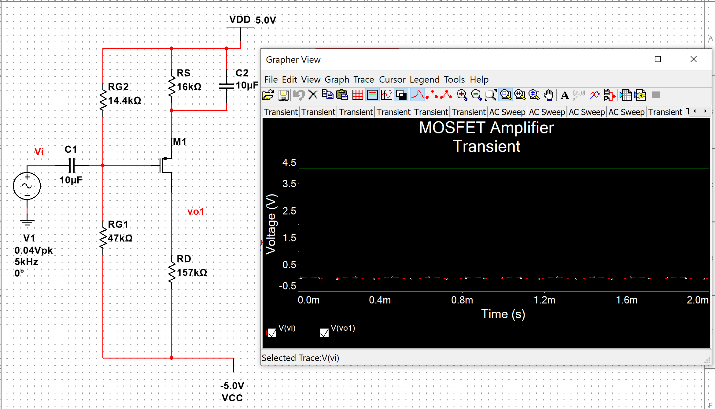

**Figure 5.1:** Time-domain waveform at **stage 1** of Vi = 40mV 5kHzfor MOSFET amplifier ▲

AV

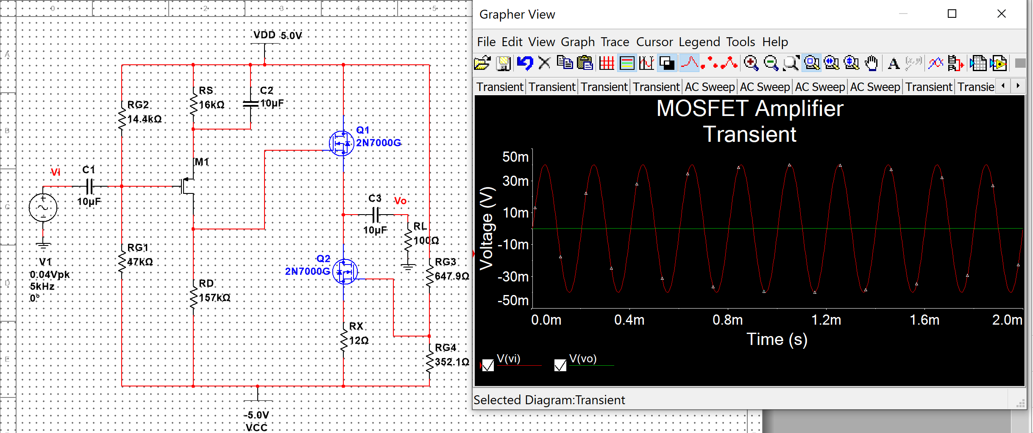

**Figure 5.2:** Time-domain waveform of Vi = 40mV 5kHzfor MOSFET amplifier ▲

AV

**Measurement**

|  |  |  |  |
| --- | --- | --- | --- |
| **CD4007P** | **2N7000G** | RD = 157kΩ | RRG1 = 46kΩ |
| λ = 0.0968 |  | RS = 16kΩ | RRG2 = 14kΩ |
| β = 1.11mA/V2 | β = 95.464mA/V2 | RX = 12Ω | RRG3 = 650Ω |
| VTh = 1.5V | VTh = 2V |  | RRG4 = 350Ω |

**Table 1:** Values usedfor MOSFET amplifier ▲

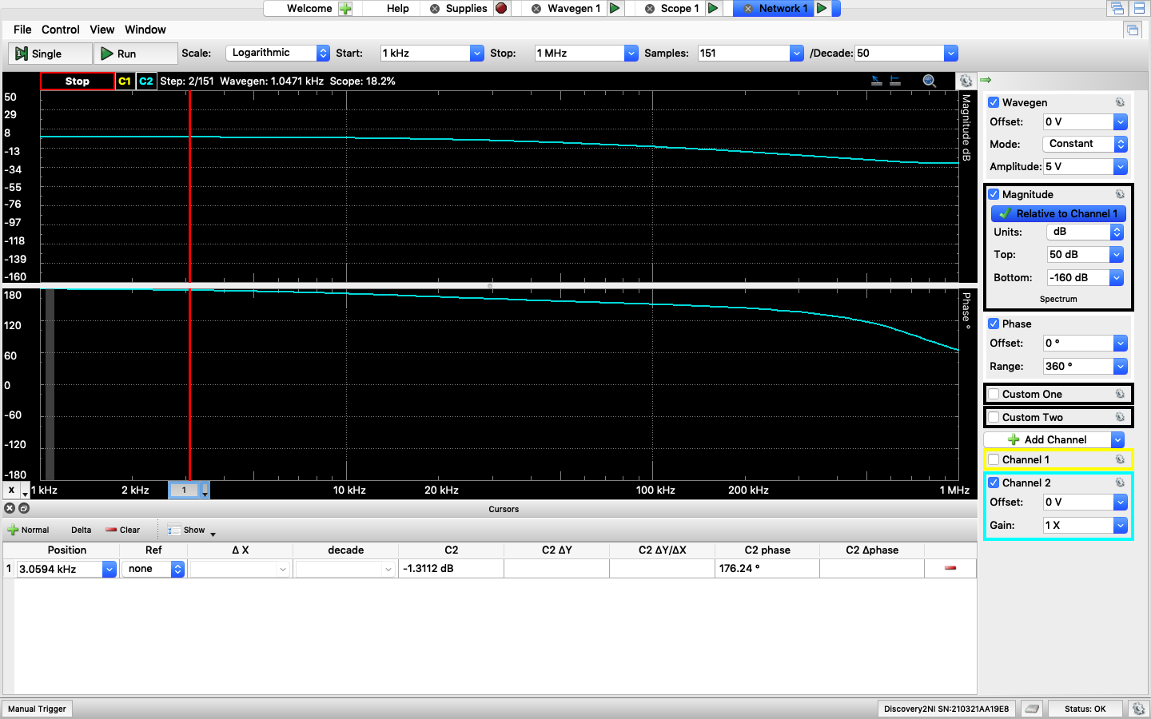

**Figure 6.1:** AV for MOSFET amplifier ▲

AV = 10^(-1.3112/20) = 0.8599

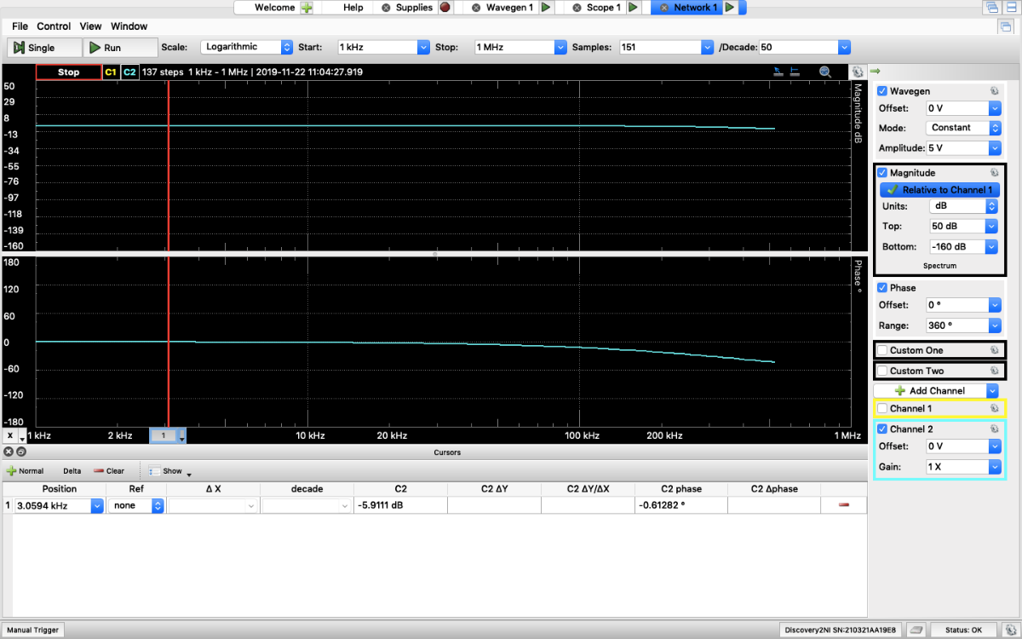

**Figure 6.2:** Ri for MOSFET amplifier ▲

Ri / (11k+ Ri) = 10^(-5.911/20)

Ri = 11.267kΩ

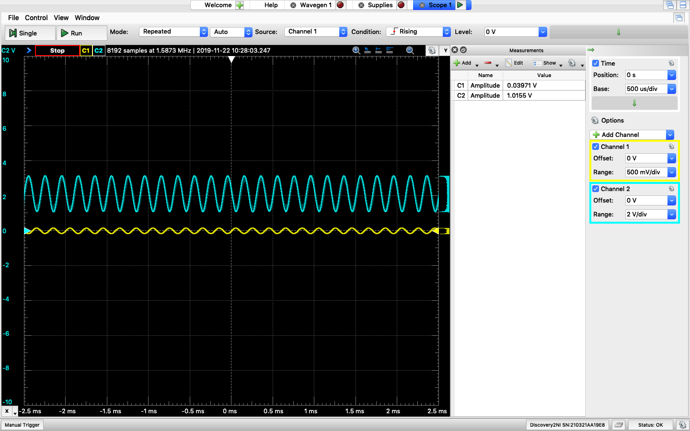

**Figure :** Time-domain waveform at **stage 1** of Vi = 40mV 5kHzfor MOSFET amplifier ▲

AV

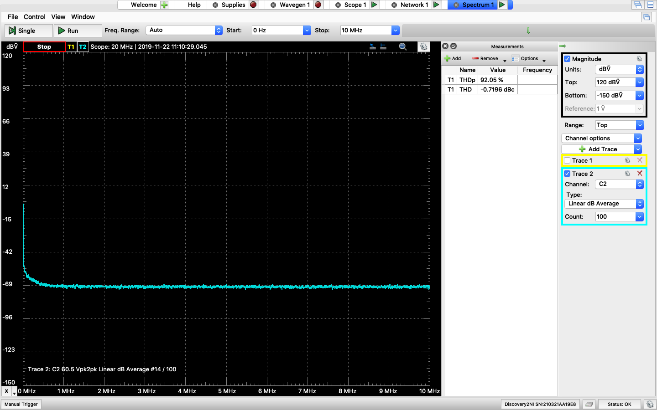

**Figure 4:** Total harmonic distortion (THD) at **Stage 1** for MOSFET amplifier ▲

THD = 92.05%

**Table**

|  |  |  |  |  |
| --- | --- | --- | --- | --- |
|  | Calculation (without Lambda) | Calculation (without Lambda) | Simulation | Measurement |
| Gain | 50 | 28 | 0 | 25.58 |
| Ri | 11kΩ | 11kΩ | 7.34kΩ | 11.267kΩ |

Stage 1



**Comment**

**Lambda value (λ):**

There is a lambda value (λ) in CD4007P that would affect the output gain. λ can be found using the characteristic circuit to find the early voltage (VA), . This λ value would affect *ro* and *ro* would affect the gain. ( ; )

In my case, I got λ = 0.0968 and my RD = 157kΩ and ID1 = 42uA. I used 50 as my ideal gain and calculated my real gain would be 28.96. In the measurement, I got a gain of 25.58 which is close to 28.96. In order for me to get a gain of 50 in measurement, I will need to use 89 as my ideal gain to calculate all the resistor values I need to use.

**Measurement:**

After I measured the stage 1 with a gain of 25, I connected it to stage 2. However, it didn’t not work as expected to give me a gain of 25. It was much lower that 25. This might have the same reason as lab 10 where Analog Discovery 2 can only handle up to 250mW. To make circuit have a gain of 25, the circuit needs to be modified to reduce the power consumption at stage 1.